Additional readings

COVID-19 and The Macroeconomic Effects of Costly Disasters (2020)
- Quantifies macroeconomic effects of costly disasters in recent US history and translates these into an analysis of the likely impact of covid-19, a global, multi-period event.
  - Unlike conventional natural disaster shocks, it also simultaneously disrupts supply, demand and productivity channels in a way that is synchronised within and across countries.
- Paper estimates the effects of the shock to be used to design policies to mitigate these impacts. Paper constructs a costly disaster time series to measure the pecuniary costs of previous disasters, and then analyses the dynamic impact of the shock on different measures of economic activity and uncertainty.
  - Macroeconomic impact of covid larger than any catastrophic event that has occurred in the past 4 decades
- Dollar cost of the covid-19 shock proxied by Coronavirus relief packages, which have so far totalled $3trn in the USA
- CD and DD series is based on dollar cost, amount of deaths, number of states affected, and event duration.
  - Covid is different to previous disasters with a much higher number of deaths, number of states affected and a much longer duration
  - Unlike previous disasters, Covid creates no damage to physical capital, but instead constrains the labour force from working efficiently

Effects of prolonged shocks
- Duration of the shock is unobservable and potentially endogenous – to the extent the shock is defined as constraining consumers and producers from economic activity, expect duration of “stay-at-home” policies is the expected duration of the shock

Conclusion
- Fairly conservative scenario with nonlinearities – large multi-period shocks like covid-19 could plausibly create a 12% monthly drop in industrial production, 55m lost jobs in service industry, sustained reductions in air traffic and heightened macroeconomic uncertainty for several months.

Global Macroeconomic impact of Covid-19: Seven scenarios
- Published in Feb 2020, so before the second waves and national lockdowns implemented across the globe
- Model considers KLEM – capital, labour, energy and materials inputs
  - Rigidities prevent the economy from moving quickly from one equilibrium to another – nominal stickiness caused by wage rigidities, cost of investment adjustment by firms with sector-specific capital

The COVID-19 pandemic will hurt long-term economic growth
IHS Markit, Johnson & Behravesh (08/2020)
- Labour force
  - As much as one-third of job losses may be permanent. Long term labour market damage will likely be concentrated by industry (travel and entertainment) and by demographic group (low-skilled workers).
  - Sustained employment can lead to people dropping out of the labour force, a sustained loss of skills and productive capacity (hysteria?)
  - Could increase labour force participation by workers with children or with disabilities / access needs (negligible impact)
- Capital stock
  - Increased uncertainty reduces appetite for investment into equipment, structures, and IP.
  - This, coupled with bankruptcies will lower the capital stock.
  - Lower utilisation rates of physical capital (planes, hotels) will lower productivity
  - Companies may be induced to substitute capital for labour, through investing into robotics
- Total factor productivity
  - Decimation of global supply chains and sharp deceleration of globalisation has worsened the productivity performance of manufacturing industries
  - Accelerated trends in digitisation could improve long run productivity
- Levels of real GDP for key developed economies could be 2-5% lower in 2030 compared to a no pandemic scenario

COVID-19’s legacy of high public debt in Europe: Prospects and problems
IHS Markit, Kral, (02/21)
- High public debts will present a vulnerability for European governments with strong incentives to stabilize and lower their debt-to-GDP ratios.
  - Austerity traditionally used to improve the primary balance thus lower debt-to-GDP ratios, however this weighs down on growth rates
  - Weak potential growth rates across Europe due to adverse demographics and structural impediments reduce the viability of austerity
- Risks of elevated public debt include a restriction on the ability of governments to pursue counter-cyclical fiscal policy stimulus during future economic downturns and private sector under-investment due to uncertainty about future taxes
- Once post-Covid-19 recovery is established, high debt burdens will need to be tackled.

Multi-speed vaccine rollouts driving Eurozone economic divergence
IHS Markit, Iscaro, 02/21
- Diverging vaccination rates may lead to a two-speed Europe developing, one in which some countries are able to reopen their economies gradually during the second and third quarters, while others stay mired in healthcare crisis and lockdown.
- Challenges faced illustrated by uneven daily vaccination rates
- Fiscal policy's effectiveness in limiting the economic impact of the recession is likely to diminish the longer the pandemic lasts. Strong fiscal support is unlikely to prevent a large number of business failures, especially in the most affected sectors. This effect has been delayed owing to several factors, including tax deferrals and fiscal handouts, but business failures are likely to pick up steam during the second quarter of 2021.
- Vaccine programme’s efficacy could also affect sentiment levels, which could in turn help unleash some of the large build up in savings that has accumulated during the pandemic
  - This would drive a pickup in consumption and to a lesser degree, capital investment
  - Household gross savings have risen from
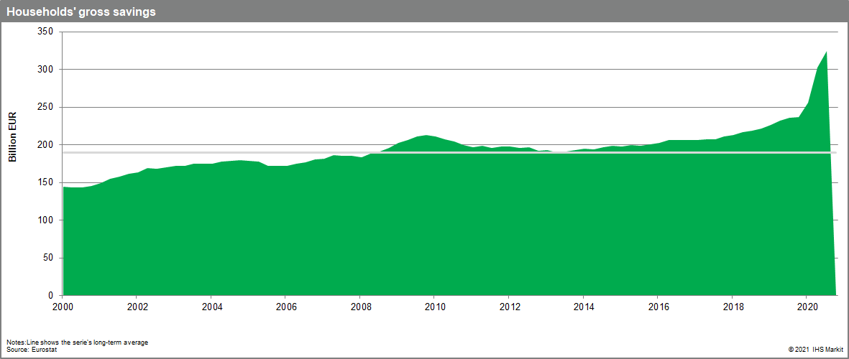

COVID-19 and Global Economic Growth: Policy Simulations with a Pandemic-Enabled Neoclassical Growth Model (Trotter et al, 2020)
- Eichenbaum et al (2020) explored the economic impacts of social distancing masures
- Ngonghala et al (2014 and 2017) shows that poverty traps arise when combining models of infectious diseases and economic development
- Model includes dynamics of capital accumulation, population growth and pandemic deaths to study the impact of the pandemic on economic growth in the long term

The model
- Assume the spread of a pandemic reduces the labour force. Assume society incurs additional direct costs which are covered with output that would otherwise be consumed or invested. Assume that government policies will impact spread of pandemic and efficiency of economic production.
- Expect reduction in infection to decline because more effective policies are implemented first, and less disruptive policies are implemented first. Infection rate exhibits a form of decreasing returns in the GDP shortfall
- Use falls in electricity consumption to proxy falls in GDP – 1% decrease in elec = 1.5% fall in GDP.
- The more you want to reduce the infection rate, the more GDP will shortfall. Exponential relationship as stricter and stricter measures are needed.
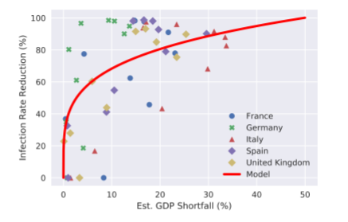

Discussion
- Our estimates suggest that a 60% reduction in the infection rate can be achieved by sacrificing only 5% of production, whereas a 70% reduction in infection rate could be achieved for a 10% reduction in production

Bank of England speech (Ramsden, 2020)
- Economic downturns reduce wages and wealth, increase unemployment and can increase inequality as these effects may be disproportionately felt by the young and low incomes.
- Long-term effects such as periods of high unemployment leading to hysteresis and skills deterioration
- Persistent negative effects on investment, innovation and productivity. However less productive firms failing can increase average productivity. Nevertheless surviving firms can have lower productivity due to falling investment and labour productivity
- MPC – long-term reduction in the supply capacity of the economy by around 1.75%.
  - 3 year forecast is a cumulative shortfall is equivalent to 22% of annual GDP, about £490bn of resources lost, either for consumption or investment, and also lost spending which would have generated tax revenues to finance gvt spending
  - Scarring effects might lower economy’s potential – lowering rate at which actual output can grow without inflationary pressure

Long-term effects of Covid
- Consumption. Spending on household goods and groceries has increased, partly offsetting falls in entertainment, travel and fuel. Most spending should return to pre-Covid levels but unclear how long this will take, composition of consumption may be different for a while
- Production – change in respond to consumption changes. How quickly retraining and repurposing can be achieved will be a key determinant of how persistent scarring is. Even in a relatively extreme scenario, less task reallocation than in 1980s
  - Some capital may be too highly specialised to be repurposed e.g. aircraft
  - Prospect of investing in new capital is low because of uncertainty as to whether demand shifts are temporary.
  - Expected impact of Covid-19 on investment by businesses in October - -25% in Q3 2020, rising up to -9% in Q2 2021.
- How we work. Evidence on the supply side effects of working from home is mixed. Longer hours (less commuting) and increased remote working could in principle be the removal of a barrier to participation by groups such as women, older workers and those with disabilities. Unclear how well results of increased productivity in specific cases generalise to overall productivity. May be that linear tasks are easier from home but complex tasks are harder

Which economies are most vulnerable to long-term effects?
- Economist – emerging markets will feel the impact of the pandemic longer than advanced economies
- Characterises long vulnerability to Covid-19 as a function of decline in GDP growth in 2020, labour market scarring, structure of economy, health-related belief scarring, economic and financial imbalances
- Modelling by Oxford economics drew evidence from past crises to create 31 measures of economic vulnerability.
- Most important predicter (decline of GDP growth this year) is larger in advanced economies. The others (labour-market rigidities and limited fiscal support) threaten emerging markets more.

Economist video
- Global GDP 7.5% down in 2020
- 15% of young employed people have lost their jobs (global)
- Low interest rats mean costs of servicing huge debts are not high – but if and when will interest rates rise.
- 60% of Americans would like to maintain some working from home
- Chief constraint on growth is the expense of living in urban areas – inequality might fall. Digital push, if embraced by government. Some victims e.g. urban service sector
- Furlough schemes can keep people locked in zombie jobs which aren’t coming back
- Direct cash transfers to households are less wasteful than fiscal stimulus
- Global supply chain disruptions

Economic and environmental impacts in France (August 2020)
- Lockdown decreased economic output by 5% but reduced CO2 by 6.6%. Both decreases are temporary. Investigate whether implementing ambitious carbon pricing speeds up economic recovery whilst significantly reducing CO2 emissions. Stimulates energy efficiency investments
- Measures restricting travel within national border and closing Schengen area improvement air quality and reduced GHGs by 30% (CITEPA, 2020).
- Current crisis an opportunity to develop inclusive and sustainable growth (Allan, 2020; Janardhanan, 2020; Rydge, 2020). Stern and Zenghelis say sustainable investments boost employment in the short term, reduce energy costs, generate economies of scale and productivity gains. Low oil prices could be a long-lasting characteristic of the post-Covid-19 economy, could slow down transition to low carbon energy sources (Helm, 2020).

Economic and environmental impacts
- GDP fell by 5% in 2020 due to collapsing aggregate demand triggered by lockdown. Increases unemployment rate. Unemployment will drop back down over the next decade. Investment fell by 11% but returns to 2.5% below baseline level by 2021
- Economic slowdown triggers instead drop in C02, but highly senstivie to oil prices collapsing – increased energy intensity and carbon intensity, stimulating economic activity. Higher levels of emission estimated in COVID and low oil scenario
Climate policy in the post-COVID recovery
- Without further climate mitigation efforts, reprieve will be short-lived. Under persistently low oil price scenario French emissions could end up higher than no pandemic by 2022
- Long-term emissions driven by changes in relative energy prices (oil markets or a carbon tax). Latter creates double dividend – energy efficiency improves, oil consumption drops, improves trade balance of net oil importers, macroeconomic benefit. Tax recycled as a lump sum tax credit, distributed proportionally to a sector’s share of total employment. Scheme favours labour-intensive industries, increasing aggregate employment
- whether implementing carbon pricing can still yield positive macroeconomic dividends in the context of the post-COVID recovery. We fnd that implementing ambitious carbon pricing speeds up economic recovery by stimulating employment and investment while reducing CO2 emissions signifcantly—even when combined with persistently low oil prices. Increasing fossil energy prices through a carbon tax leads to the substitution of energy for capital, in other words to energy efciency investments. This in turn yields a decrease in energy use and CO2 emissions. Over the long run, GDP even ends up larger than in a non-COVID-19 scenario implementing the exact same climate policy. By maintaining a high fossil fuel price, the carbon tax reduces the imports of fossil energy while fully redistributing carbon tax proceeds is primarily benefcial to the domestic economy. This acts as an additional economic stimulus which strengthens the recovery while preventing an increase in CO2 emissions. However, low oil prices delay and reduce CO2 emissions reductions achievable by a given level of carbon taxation. This underlines the need for higher carbon pricing should oil markets remain depressed in the post-COVID recovery.

Federal reserve thoughts on recovery
- US federal reserve: real GDP growth shock – 2/3s AS shock, 1/3 AD shock. Suggests recovery will be check shaped and aggregate supply driven.
- A new-Keynesian or Blanchard-Quah (1989) model would suggest recovery would be slow and incomplete because supply shocks hit productivity growth, increase NAIRU, and reduce productive capacity. If swathes of businesses (tourism, hospitality, entertainment) are no longer viable, the potential output of the economy will fall.
- If a vaccine becomes available relatively soon, or businesses find creative ways to restore operations even in the presence of continued social distancing.
- AS component falls deeper but also expected to recover faster.

Understanding coronanomics – economic implications of Covid
https://core.ac.uk/download/pdf/304661544.pdf
- (Eichengreen, 2020, 12 March
- Deglobalisation process of lockdowns preventing normal flow of goods, capital and humans.
- Baldwin and Tomiura (2020) suggest that the COVID-19 pandemic is both a demand shock and a supply shock – that are likely to slow down aggregate trade flows significantly and that a manufacturing distress and supply-side contagion is imminent through international supply chain distortions.
- Fornaro and Wolf (2020) – model showed the outbreak could open the door to stagnation traps induced by pessimistic animal spirits. If supply disruption is severe, demand-driven recession through agents’ falling expectations of future productivity.
- Service orientated economics will take larger hits – Greece, Portugal, Spain. Economic effects here are underestimated due to overreliance on historical comparisons with SARS (Fernandes, 2020).
- Demand for goods and services declines as consumers follow “savings for emergency”, “wait and see” and hoarding” during the crisis (Baldwin, 2020). Foreign demand might depress demand for exports, depressing production (supply-demand doom loop of Fornaro & Wolf). Shocks will be different for essential vs non-essential goods.
- Lesser people movement, economic uncertainty, and interrupted transport could force investors to hold back on ongoing investment plans in pandemic-affected countries. This could hit resource-scarce developing countries hardest who rely heavily on trade and FDI flows.
- Demand for essentials will rise but luxuries will plummet, overall AD will fall.
- Reduce supply of goods and service will push prices up for essential goods, but more than offset by falling prices of non-essentials. Overall deflationary pressure.
- Under these circumstances unemployment will rise due to slumping sales volume, prices and revenues. Wages bigger problem for small businesses. Unemployment rises incomes fall.
- Lack of experience amongst policymakers and researchers on how to fight a pandemic-driven recession. Need innovative and co-ordinated policies – traditional fiscal and monetary policies may prove ineffective (lower bound problem already experienced)
Observed effects so far
- Production, supply chain, demand and human movement shocks
- Effects on international trade and capital flows. Increased cost of capital through higher risk premium, reduces investment significantly. Plus delayed capital expenditure by MNCs.

Economic growth effects
- Effects on international relations and collaborations on upcoming projects
- LRAS fixed. SRAS falls. AD falls. Share of non-essential goods is bigger so these changes are felt more. Deflationary pressures and lower national output will lead to recession.
- Where credit mobilisation is disrupted, the capital stock doesn’t grow, recovery remains slow, workers exit workforce and lose skills and productivity, the shock becomes structural (Carlsson-Szlezak & Reeves, & Swartz, 2020)
What’s next?
- Dual AS and AD shocks mean governments need innovative and well-argued policies.
- Baldwin & di Mauro (2020) highlight a range of targeted fiscal and monetary measures for firms, households, healthcare, public confidence, and finance and banking
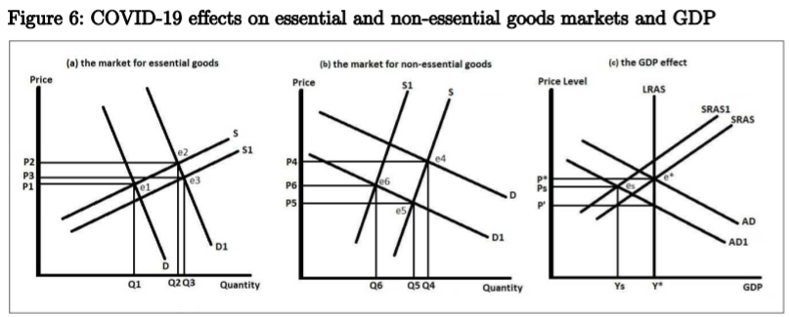
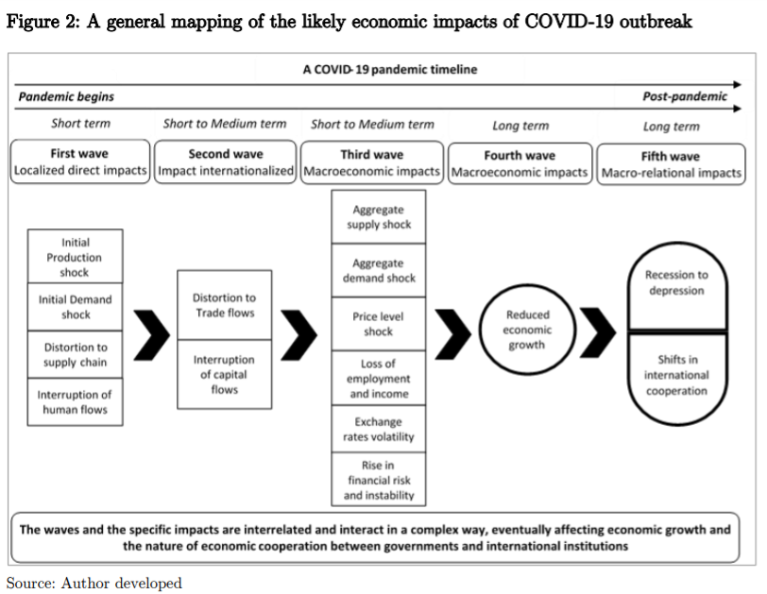

Bibliography
- https://www.federalreserve.gov/econres/feds/files/2020049pap.pdf
- https://core.ac.uk/download/pdf/304661544.pdf

